Customs to fight this growing trade fraud with AI ‘detective border’

Stuart Chirls, Tuesday, August 18, 2026
Original Article: https://www.freightwaves.com/news/customs-to-fight-this-growing-trade-fraud-with-ai-detective-border
Articles Reproduced by Permission of FreightWaves

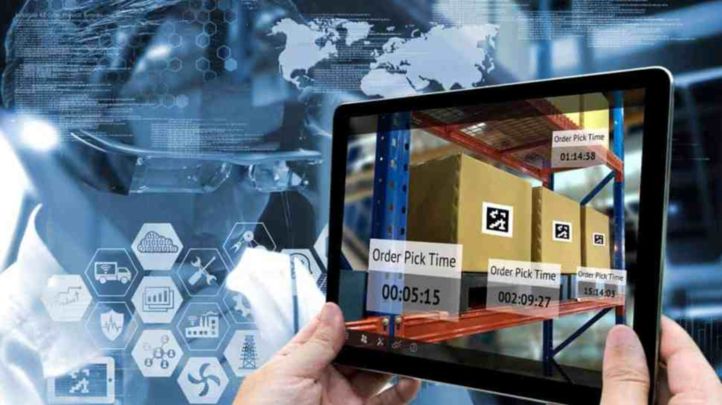
(Photo: Shutterstock/FreightWaves)

White House says U.S. struggling to keep up with tariff-fueled trade crime

A White House trade report argues that illegal transshipment of China-linked goods through third countries has grown into a global system for evading U.S. tariffs, potentially costing the Treasury tens of billions of dollars annually and placing additional pressure on U.S. manufacturing communities.

The report says exporters can exploit tariff differences by routing goods through lower-tariff countries, then relabeling, repackaging, re-invoicing or performing limited processing before shipment to the United States. Such practices can create the appearance of a new country of origin without meeting the customs threshold for substantial transformation, according to the report.

It identifies more than 40 countries as presenting elevated transshipment risk. The countries range from major trading partners with broad industrial bases such as Mexico, Canada, the European Union, India, Japan, South Korea and Taiwan to manufacturing and logistics centers such as Vietnam, Malaysia, Thailand, Indonesia, Brazil and Turkey. Smaller countries with free zones, bonded warehouses, strategic ports, lower-cost labor or limited customs-enforcement capacity also figure prominently in the report’s risk map.

The study frames the issue as an outgrowth of the trade shifts that followed the first Trump administration’s 2018 Section 301 tariffs on Chinese goods. China’s direct share of U.S. goods imports fell after the tariffs, while the combined share of imports supplied by identified transshipment-risk countries rose, the report says. It cautions that this pattern does not prove all of the reallocated trade was illegal, since some reflects legitimate investment, production relocation and supply-chain diversification. Still, it argues that the timing and scale warrant deeper enforcement scrutiny.

Estimated scale
The report draws on five government and private-sector analyses to place potential annual transshipment or trade-transfer exposure in a range from approximately $40 billion to $303 billion. The estimates are not additive and use different methodologies, the report notes.

The report uses illustrative tariff differentials of 25%, 35% and 45% to estimate potential annual revenue losses. Under the narrow $40 billion case, it calculates foregone tariff revenue of roughly $10 billion to $18 billion. Under the $75 billion central case, the range is about $19 billion to $34 billion. The broad $303 billion exposure scenario yields a range of $76 billion to $136 billion, although the report characterizes that as an upper-bound exposure measure rather than a direct estimate of illicit trade.

The Commerce Department analysis cited in the report separately estimated that approximately $67 billion in U.S.-bound goods was transshipped through Mexico, India and Vietnam in 2025 under a stricter transaction-matching methodology. The report says that estimate implied about $28 billion in lost tariff revenue.

Manufacturing impact
Beyond customs revenue, the report estimates that tariff evasion widens the effective trade deficit and displaces domestic production. Using its central $75 billion case, it estimates 450,000 direct and indirect jobs displaced, annual GDP losses of $113 billion to $150 billion, and federal revenue losses of $19 billion to $26 billion.

The study connects selected foreign hubs and product categories to U.S. industrial corridors. It cites Mexico’s Guanajuato–Queretaro region as a possible staging point for electric motors, generators, transformers and static converters that compete with production centered around Detroit, Grand Rapids, Mich., and Indianapolis. It similarly links Vietnam’s Ho Chi Minh City corridor to electrical switching equipment made in the Chicago-Milwaukee-Rockford region, and Malaysia’s Penang-Kulim cluster to plastic-products manufacturing in Akron, Canton and Upstate South Carolina.

Enforcement response
The report calls for an AI-enabled “Detective Border” that would combine shipment data, routing histories, ownership relationships, product classifications, production-capacity indicators and anomaly detection to help U.S. Customs and Border Protection identify high-risk entries.

The proposed system would be designed to distinguish legitimate foreign investment and nearshoring from pass-through trade, the report says. It envisions using link analysis, component and capacity verification, computer vision, container imaging and matched trade flows to flag potentially false origin claims or suspicious movements through free zones and bonded warehouses.

It also points to Executive Order 14411, signed June 3, 2026, as the enforcement framework intended to make importers more accountable through tougher bonding, domestic-asset, ownership-disclosure, business-affiliation and good-standing requirements, along with stronger penalties and greater trade transparency.

Why it matters: The Trump administration looking at new ways to stop trade fraud spurred in part by its own tariff strategy.

